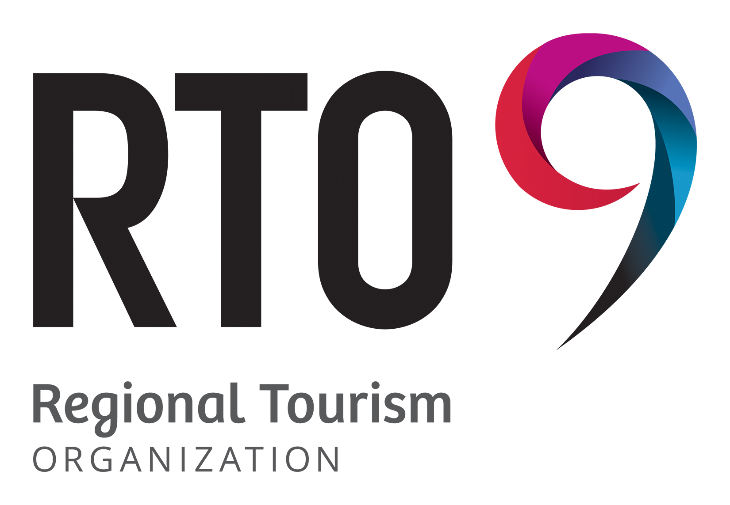

**Application for the Board of Directors of RTO 9**

Regional Tourism Organization 9 (RTO 9) is a not-for-profit organization. Its Board of Directors is made up of volunteers who focus on governance within the organization. The Board of Directors is responsible for providing direction to support RTO 9's mandate to help grow tourism across Southeastern Ontario. For further information on RTO 9, visit www.RTO9.ca.

**The Board of Directors** is structured to provide for balanced representation from across the region among key tourism sectors, as well as private and non-private industry partners. Directors are expected to have relevant board and/or management experience, leadership, skills and qualifications that would recommend them as directors of a non-profit organization. According to RTO 9 bylaws, elected officials are ineligible to serve on the RTO 9 Board. Directors must be Canadian citizens and at least 18 years of age. Directors must represent a business, corporation or organization of the tourism industry located in RTO 9, with the exception of At-Large representatives. Positions are allocated on a regional basis with a diversity of experience of skills and qualifications as per the RTO 9 General Operating Bylaws. Board composition will be focused on specific skills and competencies and geographical considerations as follows:

* 3 Western Region Representatives
* 3 Central Region Representatives
* 4 Eastern Region Representatives
* 3 At-Large Representatives (can be outside of RTO 9 boundaries)

This application form is designed to help qualify and identify candidates to serve on RTO 9’s, Board of Directors.

* Successful candidates will serve on the Board of Directors in a voluntary capacity.
* Successful candidates will serve a one, two or three year term on the Board of Directors.
* Applications will be kept in confidence and only be reviewed by the Executive Director and the Governance & Nominations Committee.

Do you accept the objects for which RTO 9 was formed and endorse its mandate as follows:

* Coordinating the diverse interests of the tourism industry within RTO 9 in order to build and support a competitive tourism region through marketing and destination management;
* Partnering with established and recognized tourism organizations and entities within the region moving forward in the spirit of cooperation and collaboration;
* Attracting and sustaining growth of tourism visitation, revenues and investment in RTO 9;
* Revitalizing and enhancing the economic and workforce development on behalf of the residents, communities and industries in the region;
* Establishing and implementing plans to enhance the tourism offerings for destinations within RTO 9 through intentional destination development;
* Establishing and implementing plans to market the tourism products and experiences within RTO 9 including the physical, natural, cultural resources and built facilities that inspire individuals and groups to visit;
* Emphasizing tourism development and marketing activities designed to attract new markets and users to the region;
* Maintaining and supporting existing tourism brands within RTO 9 that have established levels of awareness through previous destination marketing and product development investments;
* Achieving and maintaining balanced representation where no one destination, organization or sector dominates the organization for its own purpose and/or gain; and
* Fully engaging the participation of the tourism industry, provincial and municipal governments and active tourism partners within RTO 9.
* I accept the above objects
* I do not accept the above objects

Availability: this is an exciting opportunity to be part of an active, strategic governance organization that will shape the future of tourism in Southeastern Ontario. ***Directors are expected to contribute time to attend bi-monthly meetings and additional hours as required for committee participation, project work and strategic planning sessions, in addition to task teams and special event committees.*** Are you able to commit to this level of effort?

* Yes
* No

Based on the map provided, please identify which seat you are applying for:

* West seat (one-year term)
* West seat (three-year term)
* East seat (two-year term)
* East seat (three-year term)
* Central seat (three-year term)
* At Large seat (three-year term)

1. Personal Information

|  |  |
| --- | --- |
| Name |  |
| Home Address |  |
| City/Town |  |
| Telephone – Home |  |
| Telephone – Cell |  |
| Email |  |

2. Business Information

|  |  |
| --- | --- |
| Occupation |  |
| Title/role |  |
| Name of Organization |  |
| Address of Organization |  |
| Business Telephone |  |
| Business Email |  |

3. Which of the following best describes your primary occupation or interests?

* Private
* Not-Private Sector (not-for-profit or government organization)
* Other – please describe _____________________________________________

______________________________________________________________________

4. Please indicate all tourism sectors in which you have experience – use “C” to indicate current experience and “P” for past experiences.

|  |  |  |  |  |  |
| --- | --- | --- | --- | --- | --- |
| Accommodations |  | Festivals/Events |  | Indoor/ Outdoor Recreation/ |  |
| Arts and Culture |  | Golf |  | Winter Activities |  |
| Outdoor Adventure |  | Event and Meetings |  | Meetings and Conventions |  |
| Attractions |  | Agritourism |  | Municipalities |  |
| B&B |  | Fishing |  | Museums/Art Galleries |  |
| Camping |  | Food and Beverage |  | Parks and Trails |  |
| Catering |  | Halls and Auditoriums |  | Shopping/ Retail |  |
| Chambers/BIA |  | Heritage |  | Theatre |  |
| Cycling |  | Information Centres |  | Tour Operators |  |
| Culinary |  | Wine and Beer |  | Transportation |  |
| Dining |  | Leisure Services |  | Sports |  |
| Education |  | Boating/Cruising |  | Marinas |  |
| Entertainment |  |  |  |  |  |

Other: (please specify) ______________________________________________________________________

5. RTO 9 is looking for a range of experience and expertise in the areas of product/experience development and marketing. Please provide examples of how you have contributed (through work or volunteer efforts), or how your experience/expertise could assist RTO 9 in fulfilling its mandate, which is to advance the region in terms of tourism development:

1. Tourism development and training
2. Attraction of tourism investment
3. Tourism product development
4. Marketing and Public Relations in respect of tourism

6. Do you have prior experience as a member of a Board of Directors, particularly for a not-for-profit organization?

* Yes
* No

If yes, please list your experience and include current and past private or public sector boards on which you served.

7. Please indicate the types of skills and competencies you would bring to RTO 9 Board of Directors – please indicate with an “X”.

|  |  |  |  |
| --- | --- | --- | --- |
| Executive Management |  | Education/Academic |  |
| Government Relations |  | Communications |  |
| Research |  | Accounting |  |
| HR/Labour/ Workforce Development |  | Economic Development |  |
| Legal |  | Advocacy |  |
| Strategic Planning |  | Tourism/Hospitality |  |
| PR/Marketing |  | Sanitation |  |
| Transportation |  | Connectivity |  |
| Digitization |  | Automation |  |

Other: (please specify) ______________________________________________________________________

8. Do you have business management experience i.e., where you were/are responsible for overall annual results, an annual operating budget and management of staff?

* Yes
* No

9. What motivates you to be a Director of RTO 9? What benefits will you bring to the region’s tourism industry as a member of the organization?

10. Have you been involved with RTO 9 in any capacity to date?

* Yes
* No

If yes, please list:

______________________________________________________________________

11. List 2 references that support your appointment to the Board of Directors. References must not currently serve on RTO 9 Board of Directors, work for RTO 9, work for you under your supervision, or is in a conflict of interest in any other way. By providing these references, you are giving RTO 9 permission to contact for a reference.

1. Name ____________________________ Email _________________________

Telephone___________________________

Title/business/organization ____________________________________________

2. Name ____________________________ Email _________________________

Telephone___________________________

Title/business/organization ____________________________________________

Other comments (optional):

Signature ___________________________________ Date ________________

Return the completed form with your resume via email no later than **Friday, May 2, 2025, at 4:00 PM** to:

Bonnie Ruddock, Executive Director

RTO 9

bruddock@region9tourism.ca